Exercise Schedule
October 17, 2019
Player Check in: prior to 9:30 am
Exercise Player Briefing: 09:30 am
Start of Exercise (StartEx): 10:00 am
End of Exercise (EndEX) 12:00 pm
Hot Wash: 12:01 pm

GENERAL PLAYER INFORMATION

Position Roles are labeled with duties and roles on the Ventura County SWMHE website within Section 2, ROLES. The positions sheets are one of the first areas you need to review.

Injects: You will receive injects from MSEL read aloud during exercise by your Controller throughout the exercise timeline. Listen, then work on your outcome/activity.

Exercise Controllers: Each site has elected their own controller and will let you know who is in this role.

Day of Exercise Communications Plan:

PARTICIPATING AGENCY | PHONE  NUMBER
Design Team DOC | (805) 988-4089
Design Team Office | (805) 981-5301
Design Team Exercise lead (during ex play) | (805) 981-5331
Design Team Exercise lead | (805) 981-5335

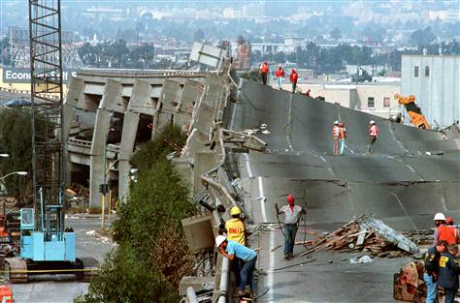
exercise documentation

Your site is required to submit at least one Situation Status Report (SitRep) during exercise play. The SitRep can be accessed via: bit.ly/vcsitrep2019.
For sites that comply with ICS: At the conclusion of the exercise, turn in all documentation. This includes activity logs (ICS 214), message forms and all other notes.

COMMUNICATIONS

Players may use telephone and, e-mail, during the exercise. Players will communicate and coordinate only with participating entities. All exercise transmissions – including the SitRep – must begin and end with the statement
“This is an Exercise.”

Questions

Direct all questions regarding exercise play to your Exercise Lead, Controller, or Evaluator.

2019 SWMHE
in Ventura County

Player Information Handout

October 17, 2019

2019 Statewide Medical & Health Exercise (SWMHE) in Ventura County

Ventura County Health Care Coalition Ventura County Public Health Department
Emergency Management Services Agency
Emergency Preparedness Office

For Exercise Participants only

exercise objectives

This exercise will focus on the following objectives:
- Immediately after shaking has subsided, players will assess safety of individuals and the integrity of the building in accordance with the site’s emergency plan and submit a Situation Status Report (SitRep) to the Ventura County Health Care Coalition.
  - Environmental Response/Health and Safety
  - Situational Assessment

- During exercise play, players will follow the Policies and Procedures for loss of power in accordance with the site’s emergency plan.
  - Emergency Operations Coordination

- Within the first 30 minutes of the exercise, players will assess their current supply levels and determine the length of time operations can be sustained.
  - Medical Surge

- Within 1 hour of StartEx, players will engage business continuity plans to assess financial impact to address how critical operations will continue.
  - Continuity of Health Care Services

Scenario
Two Weeks Prior to Exercise At the request of the California Department of Public Health (CDPH), local health departments have been working with health care coalition partners to assess their vulnerabilities in the event there is an earthquake. Authorities have requested that emphasis be placed on critical systems required to maintain operations such as emergency power, water supply, on-site disaster supplies, and building safety.
Two Days Prior to Exercise There has been an increase in inquiries both by media and elected officials on the state of preparedness among healthcare organizations and public safety agencies. The aging infrastructure as well as communication and transportation systems are being highlighted in the media reports. Of particular focus is the threat of a massive power failure that could occur if a major fault line ruptures; emphasizing concern for community members who rely on electricity for assistive technology and medical devices. Local health officials have developed guidance – Preparing for Power Outage: Persons Dependent on Electricity – to aid community members with their personal preparedness
As USGS continues to observe a heightened level of seismological activity, media outlets report a spike in sales of disaster supplies

Exercise Safety

Real-world emergencies and participant safety take priority over exercise conduct.

Safety is everyone’s concern; in a real-world emergency, notify the Controller or Safety Officer and state, “This is NOT an exercise.” Follow instructions from exercise control staff.
Assumptions and Artificialities

The FSE is conducted in a no-fault learning environment wherein capabilities, plans, systems, and processes will be evaluated.

There are no “hidden agendas” or trick questions.

Every effort has been made to create a plausible and realistic scenario to exercise and validate identified objectives.

The timeline is accelerated and time lapses are inserted to enhance participation and achieve objectives.

All Players receive information at the same time. Players will react to the information and situations as they are presented, in the same manner as if this had been a real event.

Impacts are seen across the spectrum of the response community.

Participants should use existing plans, policies, and procedures.

If a player would normally contact an individual or department that is not represented at the FSE, they should tell the Evaluator what information they need and who they would contact
EARTHQUAKE

